MNCLHD RESEARCH SUPPORT GRANT PROGRAM

Application Form
Closing Date: 8am Monday 25 July 2022

V1.0 Jun 2022

INSTRUCTIONS TO APPLICANTS

SUPPORT RESOURCES

It is strongly recommended applicants read the Research Support Grant Program (RSGP) Guidelines for Applicants prior to developing their Application. The Guidelines provide information on the eligibility and selection criteria, plus outline a number of key support resources for applicants. The Guidelines are available at: http://mnclhd.health.nsw.gov.au/research/research-capacity/grants-and-funding/
Resources for research design are available on the Office of Health and Medical Research website. This includes examples of high-quality research submissions which may assist you with structuring this application - see section ‘Before You Apply” at: www.health.nsw.gov.au/ohmr/Pages/trgs.aspx

Completing the APPLICATION Form

All applications must be submitted using this form.

All sections of this form and attachments must conform to the following:
- Left and right margins of at least 2cm.
- Font no smaller than 11-point (preferred font is Arial).
- Line spacing of 1.15.

When saving this form, please use the naming convention: RSGP2022_ Chief Investigator name (e.g. RSGP2019_JaneLEE).

Information provided in this application may be provided to advisors supporting the RSGP Review Panel for the purpose of assessment and identifying synergies between projects.

Submitting the APPLICATION

Application form and attachments must be submitted to MNCLHD-Research@health.nsw.gov.au by 8am Monday 25 July, 2022.

Two versions of the Application should be submitted:
• A Word version (excluding the certification by the Line Manager and Senior Executive Team Member).
• A full pdf version (including the certification by the Line Manager and Senior Executive Team Member).

SECTION A – OVERVIEW
Is this application specifically targeting Closing the Gap initiatives? | Yes ☐ No ☐
Chief Investigator (applicant)
Please include title/salutation
Project title
Project summary (300 words)
Summarise your research question(s) and methodology. Outline the potential benefits, including how this project will be translated into practice change that will impact patient outcomes or population health and wellbeing.
List all sites in which the project will be conducted:
Total amount requested (excluding GST)  Not to exceed $15,000  Details to be provided in Section E. | $
Project duration
Up to 18 months.
Submissions to other funding sources for this project
Include any planned or submitted applications.
List the funder, expected date of notification of success and the amount(s) requested.

SECTION B – RESEARCH PROPOSAL

B.1 Describe the problem and outline the existing evidence that you have considered before developing this proposal (150 words)
Existing evidence may be a previous quality activity undertaken, gap in the literature, if it is a policy or procedure that needs to be adapted to the local setting explain why the current document is not applicable.

B.2 What is the research question to address the problem? (100 words)

B.3 Indicate where, on the research translation path, current evidence exists and where this proposal sits. 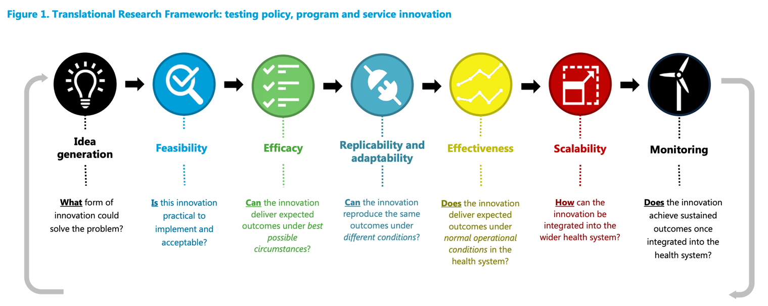
Source: Translational Research Framework, available on the TRGS website.
 | Idea generation | Feasibility | Efficacy | Replicability and adaptability | Effectiveness | Scalability | Monitoring
Current
Proposed research

B.4 Describe the approach, including research design and methods and outcomes (300 words)
Include details such as study design, methods, participants and setting, outcomes, data sources/research tools, data collection methods and analysis plan.

B.5 Milestones
Provide a timetable for key project milestones (e.g. ethics approval, site/participant recruitment, completion of data collection, data analysis, final reporting). Add rows as necessary.
Key milestone | Achievement date (mm/yyyy)

SECTION C – RESEARCH TEAM

C.1 Chief Investigator details
The Chief Investigator (applicant) must be employed by the MNCLHD.
The Chief Investigator(s) is/are expected to steer the project and be actively involved in the research.
Full Name
Position
Contact phone number
Email

A Co-Chief Investigator (optional) may be external to the MNCLHD e.g. university partner.
Full Name
Position & Organisation
Contact phone number
Email

C.2 Associate Investigator(s) and research partners
Include other proposed investigators in this section (maximum 5). Partners are unlimited.
Associate investigators may include senior researchers, managers, policy makers and clinicians from a range of organisations.

Associate Investigators
# | Full Name | Position | Organisation | Contribution
1
2
3
4
5

Partners
Partners are identified as those external to the Chief Investigator’s “home” department and essential for the successful conduct of the project and implementation of the outcomes.
(e.g. LHD Director of Clinical Governance, Site Director of Nursing, Network Manager of Community and Allied Health).

# | Full Name | Position | Department
1
2
3
4
5
6
7
8
9
10
11 | Add rows as required.

SECTION D – TRANSLATIONAL PLAN AND IMPACT

D.2 Describe how the results of this research are likely to improve clinical practice and/or patient outcomes?
Consider generating evidence for policy/practice change and/or patient outcomes and for who.

Note the activities and responses in questions D.2 and D.3 are not expected to occur within this project but is intended to ensure applicants have considered how the findings will be disseminated, translated or implemented.
D.2 If the findings are proven to be successful, what will you need to do to translate this knowledge, and how will you approach this?
Please consider how different mechanisms will be utilised to support translation: i.e. publication; presentation; peer engagement; media (including social media); training (identify who); consumer/patient education; funder engagement; clinical guideline and/or policy change; colleges; national bodies and other key stakeholders etc.
Mechanism  e.g. publication, guideline, education/training, conference | Activity  e.g. deliver training to general ward nursing staff, publish journal article | Anticipated Impact

D.3 How will you know that the translation of this knowledge into practice/policy/patient outcomes has been successful?

SECTION E – REQUESTED BUDGET

Please provide details of requested funds and co-contributions. The requested funds should include all anticipated RSGP funding required for the research project and activities to support translation. For salaries, please specify the salary level, on-costs (25.7%) and FTE.
Note the requested funding allocation in the table below (E.1) will be used for the budget allocation over the two financial years. The funds must be expended within the financial year of issue. The Research & Knowledge Translation Directorate does not have authorisation to quarantine unspent funds.
It is anticipated that successful applicants will receive Year 1 funding September 2022.

E.1 RSGP funding requested
Grants range from $5,000 to $15,000 over 18 months.

Budget Item†  e.g. Salary – must include 25.7% on-costs (CI, AI, research assistant, non-standard of care investigations) | Funding requested  (excl. GST) |  | Description  (<100 words per item)  e.g. Project management, data collection, data analysis
 | Year 1  (2022/23)  From Sep 2022 | Year 2 (2023/24)
TOTAL | $ | $
† RSGP funding may be used for costs associated with the research project and translation activities but cannot be directed towards conference attendance (including travel and accommodation), publication costs, capital works, general maintenance costs, telephone/communication systems, basic office equipment such as desks and chairs, rent or the cost of utilities.

E.2 Cash contributions
Cash contributions may include other grant awards or program funding already received.
Source  e.g. Successful ACI Grant | Budget item | Funding (excl. GST) |  | Description  (<100 words per item)
 |  | Year 1 (2022/23) | Year 2 (2023/24)
 | TOTAL | $ | $

E.3 In-kind contributions
Source  MNCLHD or Partner Organisation e.g. University | Budget item  e.g. Research design and statistical support | Description  (<100 words per item)  e.g. 20 hours of support
.

SECTION F – CERTIFICATION BY LINE MANAGER AND SENIOR EXECUTIVE

I certify that:
- The appropriate financial and/or in-kind support for the research as described in this application will be provided.
- All funds awarded as part of the RSGP will be used only for the purpose for which they were awarded.
- Practice change will be implemented based on the results of the research.
- I note that this Application will be reviewed by the RSGP Review Panel.

____________________________________
<Insert Name>
Line Manager, <Insert Department/Ward>

____________________________________
Date

Senior Executive Team Member:

____________________________________
<Insert Name>
Director, <Insert Directorate>

____________________________________
Date

If this certification is not signed by the Line Manager and Senior Executive the Application is not valid.

Sax Institute, Translational Research Framework: Testing innovation in policy, programs and service delivery, 2016. Available from https://www.medicalresearch.nsw.gov.au/designing-research-study/

